# Two Way Communication

Create new application

* ng new communication

create new component

* ng g c child

# Let’s make Parent to child communication using input

App.component.html

<div class="container">

  <h1>Two Way Communication</h1>

  <h2>Parent Sending a Data To Child</h2>

  <input (keyup)="0" type="text" #pdata>

</div>

<app-child [pdata]="pdata.value" ></app-child>

child.component.ts

import { Component } from '@angular/core';

@Component({

  selector: 'app-child',

  templateUrl: './child.component.html',

  styleUrls: ['./child.component.css'],

  inputs:['pdata']

})

export class ChildComponent {

  pdata:string="";

}

Child.component.html

<div class="container">

    <h5>Value coming from parent:</h5> <b>{{pdata}}</b>

</div>

Install bootstrap

* npm install bootstrap

import bootstrap in style.css file

/* You can add global styles to this file, and also import other style files */

@import '../node_modules/bootstrap/dist/css/bootstrap.min.css';

Save all the files and run the app

* ng serve

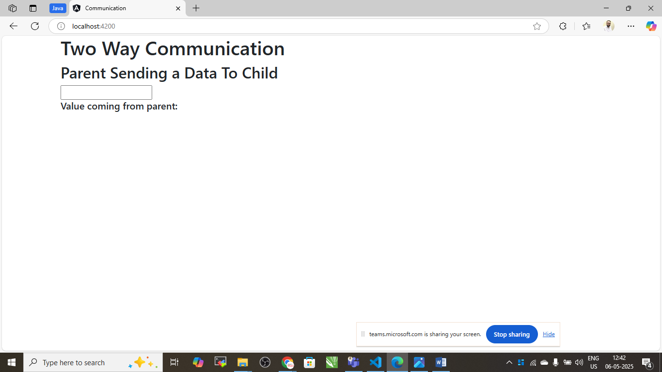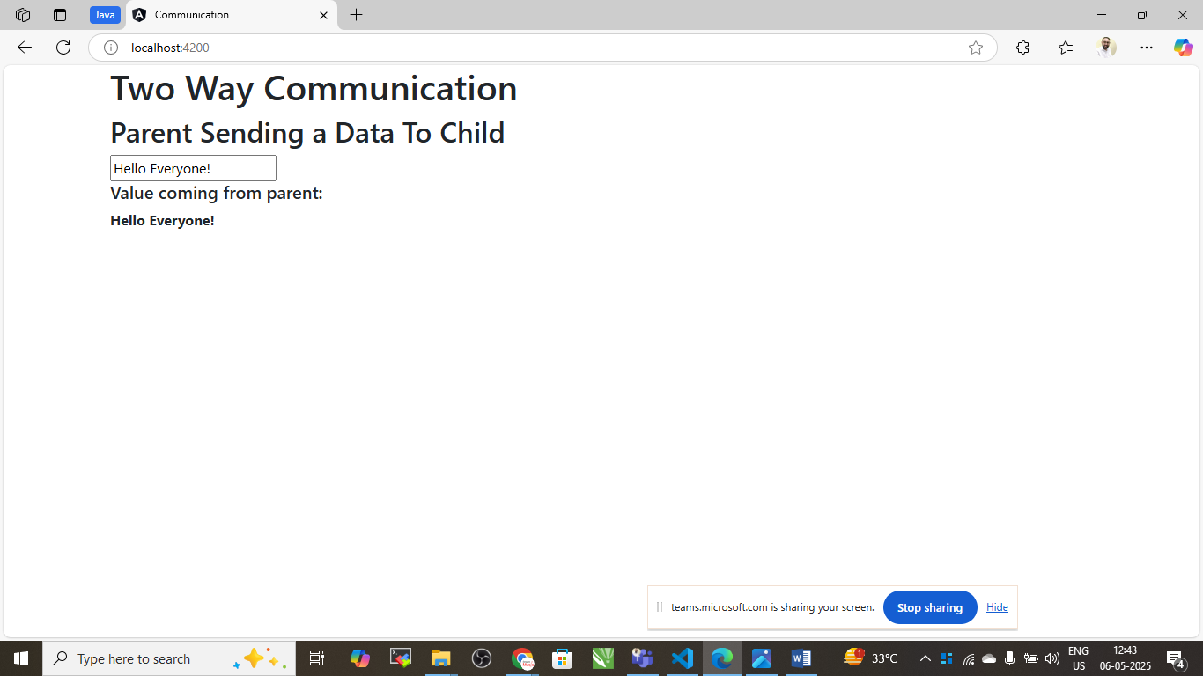

# CHILD TO PARENT COMMUNICATION USING EVENT EMITTER

Child.component.html

<div class="container">

    <h5>Sending data from Child to Parent</h5>

    <input type="text" #cdata (keyup)="onChange(cdata.value)"/>

</div>

Child.component.ts

import { Component, EventEmitter } from '@angular/core';

@Component({

  selector: 'app-child',

  templateUrl: './child.component.html',

  styleUrls: ['./child.component.css'],

  inputs:['pdata'],

  outputs:['cevent']

})

export class ChildComponent {

  pdata:string="";

  cevent= new EventEmitter<String>();

  onChange(value:string){

    this.cevent.emit(value);

  }

}

App.component.html

<div class="container">

  <h1>Two Way Communication</h1>

  <h2>Parent Sending a Data To Child</h2>

  <input (keyup)="0" typ e="text" #pdata>

  <h2> Value coming from child</h2> <b>{{cdata}}</b>

</div>

<app-child  [pdata]="pdata.value" (cevent)="cdata=$event" ></app-child>

App.component.ts

import { Component } from '@angular/core';

@Component({

  selector: 'app-root',

  templateUrl: './app.component.html',

  styleUrls: ['./app.component.css']

})

export class AppComponent {

  title = 'communication';

  cdata:String="";

}

